Puget System
SR | USER Requirements | GPT Results | VeriGen Results
 | The system captures files and manage files where appropriate. | Missing | 1. The system shall be able to capture files.2. The system shall be able to manage appropriate files where.
 | The system allows for multiple file upload to be configured on a per-page basis. | 2 The system shall provide users with the ability to upload multiple files simultaneously.  3 The system shall be able to configure the maximum number of files that can be uploaded on a per-page basis. | 3. The system shall be able to allow for multiple file upload to configured on a perpage basis.
 | The system captures and organize voice clips that can be used where appropriate. | 13 The system shall provide users with the ability to capture voice clips. | 4. The system shall be able to captures appropriate voice clips that used where.
 | The system allows actors to organize their voice clips into a portfolio. | 15 The system shall provide users with the ability to organize voice clips into a portfolio. | 5. The system shall be able to allow to organize their voice clips in to a portfolio.
 | The system allows actors to download their voice clips in a flexible format. | 17 The system shall provide users with the ability to download their voice clips.  18 The system shall be able to provide multiple audio file formats for downloading voice clips. | 6. The system shall be able to allow to download their voice clips in a flexible format.
 | The system stores audio clips in a format conducive to speech. | 19 The system shall store audio clips in a format conducive to speech, such as WAV or MP3. | 7. The system shall be able to store audio clips in a format conducive to speech.
 | The system allows actors to delete recorded clips. | 20 The system shall provide users with the ability to delete recorded voice clips from their portfolio. | 8. The system shall be able to allow to delete recorded clips.
 | The system displays web feeds, such as RSS 2.0 feeds, for all pages of the course management system where elements such as forum posts, assignment postings, announcements, wiki alterations and other blocks of information that an actor may view are added. | 24 The system shall provide users with the ability to view web feeds (e.g., RSS 2.0) for all pages of the course management system.  25 The system shall be able to generate web feeds for forum posts.  26 The system shall be able to generate web feeds for assignment postings.  27 The system shall be able to generate web feeds for announcements.  28 The system shall be able to generate web feeds for wiki alterations.  29 The system shall be able to generate web feeds for other information blocks that users may view. | - The system shall be able to display web feeds , such as rss 2.  10. 0 feeds , for all pages of the course management system where elements such as forum posts , assignment postings , announcements , wiki alterations and other blocks of information that an view added.
 | The system allows web feeds to be turned on or off on a per-page basis. | 32 The system shall be able to turn web feeds on or off for individual pages. | 11. The system shall be able to allow feeds to turned on or off on a perpage basis.
 | The system uses search functionality as a way to navigate Moodle pages instead of using hierarchical links. | 34 The system shall provide users with the ability to search for Moodle pages using a search box. | 12. The system shall be able to use search functionality as a way to navigate moodle pages instead of using hierarchical links.
 | The system displays a search box on every page after an actor has logged in. | 35 The system shall display a search box on every page after a user has logged in. | 13. The system shall be able to display a search box on every page after an logged in.
 | The system allows actors in the capacity of course administrator to post grades associated with assignments for a particular actor in the capacity of student. | 42 The system shall provide course administrators with the ability to post grades associated with assignments for students.  43 The system shall provide course administrators with the ability to select a student when posting grades. | 14. The system shall be able to allow in the capacity of course administrator to post grades associated with assignments for a particular actor in the capacity of student.
 | Administrator grades an assignment. | Missing | 15. The system shall provide administrator with the ability to grade an assignment.
 | The system displays grade information to the appropriate actor. | 48. The system shall display grade information to the appropriate student. | 16. The system shall be able to display grade information to the appropriate actor.
 | The system maintains a grade history. | 50 The system shall maintain a history of all grades posted for assignments. | 17. The system shall be able to maintain a grade history.
 | The system provides a wiki where actors can collaboratively create networks of documents. | 53 The system shall provide a wiki where users can collaboratively create and edit documents. | 18. The system shall be able to provide a wiki where collaboratively create networks of documents.
 | The system provides a blog engine. | 58 The system shall provide a blog engine for users. | 19. The system shall be able to provide a blog engine.
 | Students selects in their preferences whether notifications are sent to their mobile telephone (via SMS) or e-mail account. | 62 The system shall provide students with the ability to select their notification preferences.  63 The system shall provide students with the ability to choose between receiving notifications via SMS or email. | 20. The system shall provide students with the ability to select in their preferences whether notifications sent to their mobile telephone via sms or email account.
 | Students manages their notification subscriptions (for example, remove themselves from notifications). | 64 The system shall provide students with the ability to manage their notification subscriptions.  65 The system shall provide students with the ability to remove themselves from notification subscriptions. | 21. The system shall provide students with the ability to manage their notification subscriptions for example , remove themselves from notifications.
 |  | 1 The system shall provide users with the ability to upload files.
 |  | 4 The system shall provide users with the ability to manage uploaded files.
 |  | 5 The system shall provide users with the ability to organize uploaded files into folders or categories.
 |  | 6 The system shall be able to validate the file type during upload and reject unsupported file formats.
 |  | 7 The system shall be able to validate the file size during upload and reject files that exceed the configured limit.
 |  | 8 If a file upload fails, then the system shall display an error message indicating the reason for the failure.
 |  | 9 The system shall provide users with the ability to delete previously uploaded files.
 |  | 10 The system shall provide users with the ability to rename uploaded files.
 |  | 11 The system shall provide users with the ability to download uploaded files.
 |  | 12 The system shall provide users with the ability to view a list of all uploaded files on a page.
 |  | 14 The system shall provide users with the ability to upload voice clips.
 |  | 16 The system shall provide users with the ability to categorize voice clips within their portfolio.
 |  | 21 The system shall provide users with the ability to preview voice clips before downloading or deleting.
 |  | 22 If a user attempts to delete a voice clip, then the system shall prompt for confirmation before deletion.
 |  | 23 If a voice clip is deleted, then the system shall remove the clip from the user’s portfolio.
 |  | 30 The system shall provide users with the ability to subscribe to web feeds on a per-page basis.
 |  | 31 The system shall provide users with the ability to unsubscribe from web feeds on a per-page basis.
 |  | 33 If web feeds are turned off for a page, then the system shall not generate or display web feeds for that page.
 |  | 36 The system shall be able to return search results that match the entered keywords.
 |  | 37 The system shall be able to search across all Moodle pages, including forums, assignments, announcements, and wikis.
 |  | 38 The system shall be able to handle empty search queries by displaying an appropriate message.
 |  | 39 If no search results are found, then the system shall display a message indicating that no results were found.
 |  | 40 The system shall be able to handle invalid search inputs by displaying an error message.
 |  | 41 The system shall provide users with the ability to navigate to a page directly from the search results.
 |  | 44 The system shall provide course administrators with the ability to select an assignment when posting grades.
 |  | 45 The system shall provide course administrators with the ability to enter a grade value for an assignment.
 |  | 46 The system shall validate that the entered grade value is within the allowed range for the assignment.
 |  | 47 If an invalid grade value is entered, then the system shall display an error message and prevent submission
 |  | 49 The system shall display grade information to the course administrator who posted the grade.
 |  | 51 The system shall provide users with the ability to view the grade history for a specific assignment.
 |  | 52 The system shall provide users with the ability to view the grade history for a specific student.
 |  | 54 The system shall provide users with the ability to create new wiki pages.
 |  | 55 The system shall provide users with the ability to edit existing wiki pages.
 |  | 56 The system shall provide users with the ability to view the history of changes for each wiki page.
 |  | 57 The system shall provide users with the ability to revert a wiki page to a previous version.
 |  | 59 The system shall provide users with the ability to create blog posts.
 |  | 60 The system shall provide users with the ability to edit their own blog posts.
 |  | 61 The system shall provide users with the ability to delete their own blog posts.
 |  | 66 The system shall validate that a student’s selected notification method (SMS or email) is properly configured before enabling notifications.
 |  | 67 If a student’s notification method is not configured, then the system shall prompt the student to configure it before enabling notifications.
 |  | 68 The system shall send notifications to students based on their selected preferences.
 |  | 69 The system shall provide feedback to students when their notification preferences have been updated successfully.
 |  | 70 The system shall display an error message if there is a failure in updating notification preferences.

Class Diagram (GPT)

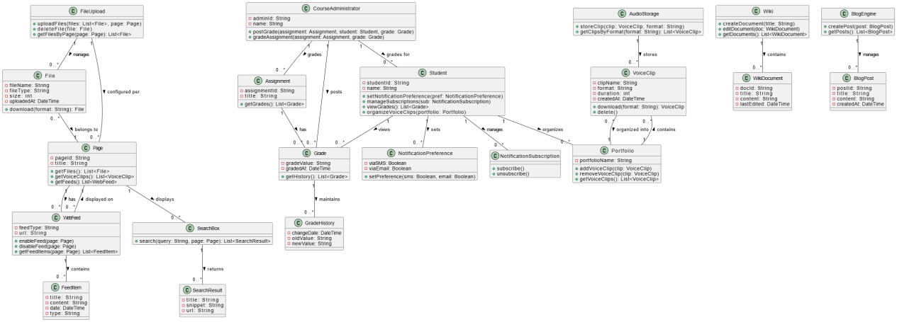

Class Diagram (VeriGen)

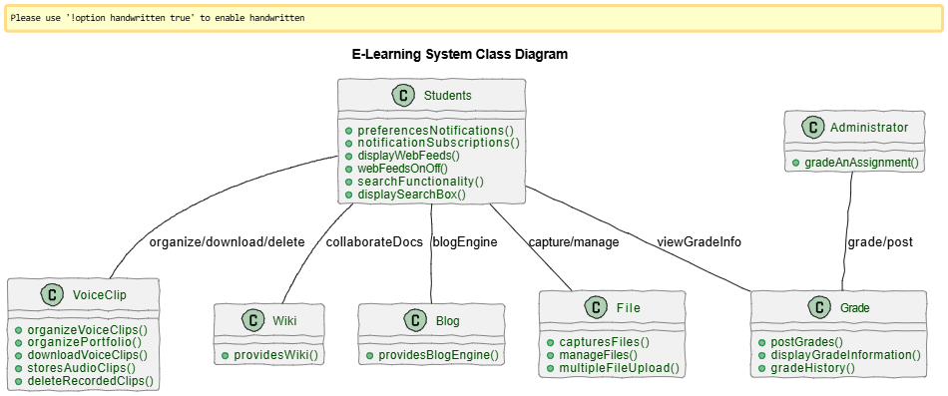

Sequence Diagram (VeriGen)

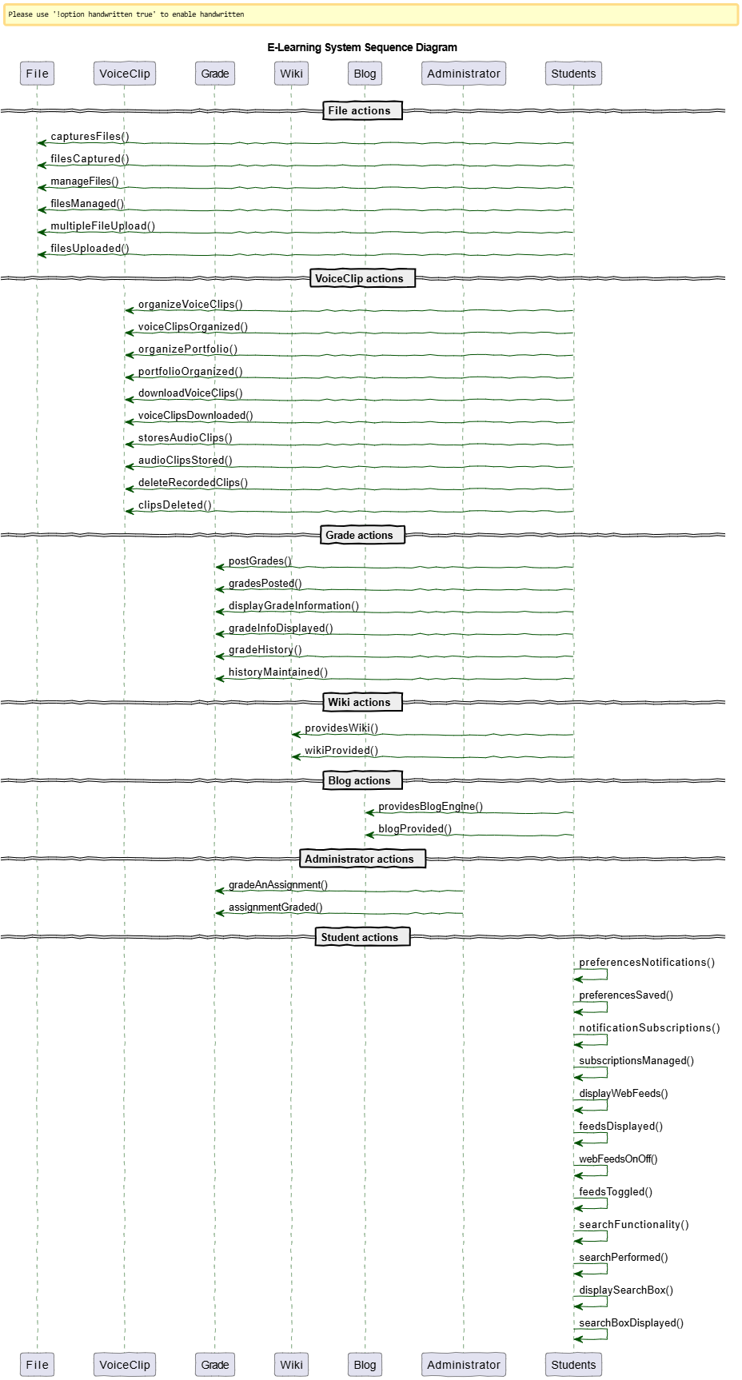
Sequence Diagram (GPT)

